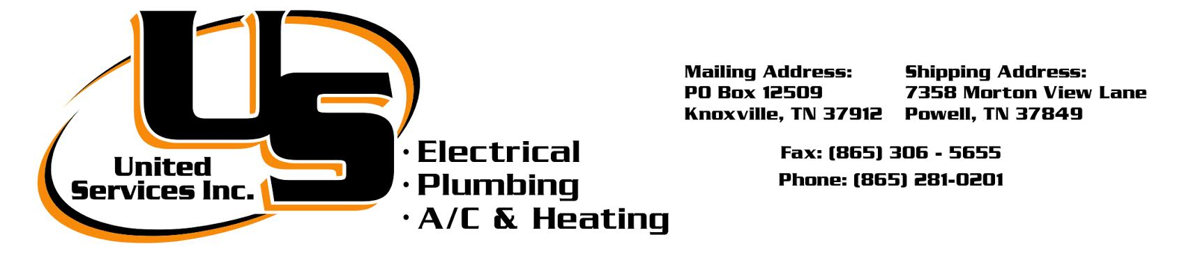

January 21, 2026

To: Estimator\Project Manager
From: Zach Buck
TN LIC # 47699
Expiration Date: 10\31\2027
Classification: State of Tennessee Electrical Contractor (CE)
Classification: State of Tennessee Mechanical Contractor (CMC)
Subject: ORHA Elks Community Enrichment Center
Addenda:

Plumbing Scope Of Work: Sanitary Sewer (PVC), Domestic Water (PEX), Insulation, Fixtures, Recirc Line, Concrete Cutting, Core Drilling For Man Hole Only. Sewer Goes To Manhole And Tap Made In Manhole & Sealed. Existing Sewer tying Into New Piping. Water Goes To Water Meter. $10,000 Allowance Included For Tap Fees & Meters. PVC & PEX Piping For All Site Work.

Pricing Good For 30 Days. Pricing Taken From Plumbing Drawings Only.
These Items are Excluded unless noted Above: Roofing, Painting Of Gas Piping, Line Voltage, Boring, Concrete Pads For Condensers, Housekeeping Pads, Sheetrock Access Doors, Patching of Walls or Ceilings, No Seismic, Bonds, Pouring or Patching Concrete Floors, Spoils off of Site, Structural Steel, Rock Removal, Unsuitable Soils, Downspout Drains, Roof Drains, No Tap Fees, No Manholes, No Storm Drain Structures, No Low Voltage Wiring, No Meter Fees. All Work Done During Regular Hours. No Overtime, Nights Or Weekends Included Unless Specified.

Plumbing Quote: $134,615.00

United Services Inc. (865) 281-0201
Zach Buck Plumbing Estimator & Project Manager (865) 771-9421

